
CITY OF PENDERGRASS GEORGIA
2024 FISCAL YEAR BUDGET





June 27th, 2023

Citizens of Pendergrass,

It is my pleasure to submit to you the Fiscal Year 2024 Proposed Operating Budget for the City of Pendergrass. The forecasted revenues for FY 2024 equal our anticipated expenditures of $2,109,024.00. The FY 2024 budget strategically builds upon our FY 2023 objectives. The City’s Annual Operating Budget is a financial proposal that annually directs the provision of public services and facilities. This plan represents the Mayor and City Council’s commitment to provide for the most important citizen needs within the boundaries of available revenue funds. Overall, this proposed FY 2024 Budget forwards our community’s quality of life. The FY 2024 Budget supports fundamental City services at a high level of quality including public safety and infrastructure maintenance. This proposed budget supports the greater building of our community physically, socially, and economically through further development of our human capital and investments in our town.

The City of Pendergrass’s largest reoccurring source of revenues are property taxes and franchise fees. Property taxes are made up of real and personal property and motor vehicle taxes. In FY 2024, we anticipate that property taxes will generate 37.55% (or $792,000.00) of the budget to operate the City. This tax category is made up of real and personal taxes (homes and land) and motor vehicle taxes. This growth is a result of reassessments of existing real property and new development. In FY 2024, we anticipate that 7.11% ($150,000.00) of City income will be derived from franchise fees, which consists of electric, gas, cable, telephone and cell/fiber and telecommunications. Franchise fees are charges to utility companies for the privilege of operating within municipal boundaries. In FY 2024, we anticipate that 21.62% ($662,000.00) of City revenue will be generated via the county wide local option sales. These taxes are levied on the sale of goods and services within Jackson County. These taxes are collected in addition to the statewide sales tax collected by the Georgia Department of Revenue. Local option sales taxes are divided among the County and Cities based on negotiations between the Cities and County and are generally distributed according to population numbers.

In FY 2024, Personal Services and Employee Salaries and Benefits will account for approximately 65.03% of normal City expenditures, an increase of 6% of the total budget over last year. Primary contributors to this increase include marketing adjustments to salaries, specifically police officer pay. We have identified staffing needs for the police department for 2024 and beyond and are budgeting accordingly. This city began a pattern of growth some four years ago. It is upon us now. It is now our duty to protect and police our city at the levels necessary to provide a safe, enjoyable community for all. We must focus on investing in our human capital in order to retain the very best public servants in Georgia. The figure above includes adding additional police officers and Environmental Services Employees to the city work force in FY 2024.

Years of planning and community input helped shape the City’s vision to achieve a balanced mix of residential and commercial developments. The City began back in 2016 to promote and attract businesses to its commercial overlay district along the U.S. 129 By-Pass. This transportation node will experience significant transformation in FY 2024 and beyond and will become an ever-increasing source of revenue for the City.

We take great pride in the City’s approach to development. Instead of a passive hope that we might attract the right mix of commercial growth, we actively seek businesses that are a good fit for our community; ones that will enhance the character of Pendergrass. We apply marketing strategies with our commercial real estate partners focusing on specific industry segments that will help Pendergrass attract the right mix of development that will result in long-term sustainability for our community.

The City provides a full range of services including Police, Library, Environmental Services, Code Enforcement, Municipal Court, Planning and Zoning and Parks.

The City’s overall financial condition is good. Macro-economic factors such as the costs of health insurance, gas, housing, food and basic necessities will influence consumer personal purchasing habits, thus affecting county wide sales tax collections. Over the years, the City Council has made strategic decisions that have properly positioned the City to withstand financial stress. We limit the use of long-term debt and have been successful in promoting development along our 129 By-Pass, thus increasing our potential tax base. We will not increase our millage rate in FY 2024. We will increase the value of your properties and provide you with a beautiful City to live, work and play in. We do not waste money on unnecessary employees. Many of our employees “wear many hats” and perform multiple functions for this City. We will maintain tight fiscal policies and be outstanding stewards of taxpayer dollars.

The development of this FY 2024 Budget is a significant undertaking by our department heads and staff. I sincerely appreciate the efforts, contributions and sacrifices made by our City employees every day to ensure the best possible financial outcome for the City of Pendergrass.

The objective of the City’s budget is to provide management with a tool and structure to the intentions of the governing body. The budget process results in the updating of the City’s on-going financial plan and provides a vehicle in which management decisions can be made as a result of the formulation of the respective data.

To all, it is our pledge that, with your support, we will maintain sound financial policy and keep the City of Pendergrass the best place to live, work and play in the State of Georgia.

It is my great privilege to serve as your Mayor.
As always, my door is open to all.

Nick Geiman



Georgia Economic Overview

Known as the Empire State of the South or the Peach State, Georgia is currently ranked 12th in the United States for its economic performance. Over the five-year period from 2015-2020, Georgia has been economically outperforming the nation. During this period, Georgia’s gross domestic product (GDP), the value of all the goods and services produced in the state, reached $533.57 billion in 2020. There was a dramatic decline in the GDP growth rate in 2020 due to the coronavirus (COVID-19) pandemic, although signs of recovery began to appear in 2021. Additionally, according to the U.S. Bureau of Labor Statistics, the state has recorded an unemployment rate of 2.6% at December 2021, while the United States recorded an unemployment rate of 3.9%. The most critical driver of growth in Georgia has been an influx of laborers and businesses to the state. Businesses have been attracted to the state due to a comparatively lower cost of living. The median home price in Georgia is $245,778 well below the national median which is at $293,349. This has attracted many to the state, boosting the real estate, rental, and leasing sectors. Overall, demand for housing is strong and homes are being sold at a faster pace in Georgia than they are nationally. Construction activity in the state has been strong, with the value of private nonresidential construction at $10.75 billion in 2019. Georgia has experienced unparalleled opportunity and economic success. The state has weathered the 2007 – 2009 recession: emerging stronger than ever. Wages are on the rise, unemployment rates continue to drop, and the state has been a preferred destination for business. The City’s real estate growth is reflective of the positive movements that can be seen in the state and national economies. With the enduring economic expansion across Georgia, Pendergrass remains on a path of continued and sustainable growth. Although Georgia’s local governments are affected by the condition of state and federal finances, they rely heavily on property taxes as a major source of revenue. In the wake of the recession, falling house prices created a challenge for local government finances, but home prices have been on the upswing for many years. In 2018, the statewide, purchase-only house price index stood at 14 percent above the 2007 pre-recession home price peak. Georgia’s home prices have climbed 58% since the market bottomed-out in 2012. However, price recovery is uneven and proceeds more slowly in some areas of the state. In smaller towns and rural areas, home values are still below the pre-recession peak, with 95 percent of value recovered, on average, in 2018.




Real estate prices and development are primarily driven by factors such as a property’s location, area development limitations, access to and sustainability of mortgage rates, personal and household income, as well as supply and demand trends as influenced by the dynamics of the local and national economy, to name a few. Some key performance indicators of these effects to be considered include rates of homeownership, per capita and household incomes, building permits issued, population growth, and property values. According to the USCB’s American Community Survey performed in 2020, median household income in Pendergrass reached $60,750.00. Income plays an important role in determining the health of a given real estate market as it can shed light upon the ability of residents to sustain themselves as well as maintain their mortgage obligations. The City’s 2023 Adopted Budget suggests a greater potential resiliency for the City of Pendergrass in the face of possible future market fluctuations, cyclical or otherwise. The City’s tax base has increased over the past five years. The City’s population has grown by 300%, from 2010 to 2020, according to data most recently made available by the USCB. Generally, increases in population levels over a relatively brief period can heighten the demand for property in a given area, and can consequently drive-up prices. The real estate market in Pendergrass has been moving in a steady upward direction in recent years.





FISCAL YEAR 2024

Budget Guide

The city’s charter requires the City Mayor to prepare an annual budget. The budget document is the result of months of planning. The budget allocates the city’s limited financial resources to provide services based on organizational and community priorities. The resulting document becomes the plan that guides departments’ operations throughout the fiscal year. The budget period is the city’s fiscal year which begins on January 1 and ends on December 31. While budgeting is an ongoing process, departments officially submit budget requests to the City Administrator in March. A detailed budget schedule is attached. Georgia state law requires that the operating budget be balanced with current revenues and other financing sources, including unreserved fund balance.

Budgetary Funds

The City’s accounts are organized by fund groups, each of which is treated as a separate accounting entity. Annual operating budgets are approved for the following funds:
General Fund: The general operating fund of the city. It accounts for resources traditionally associated with government that are not required to be accounted for in another fund.

SPLOST Fund: Established to account for the receipt and expenditures of money from the Special Purpose Local Option Sales Tax (SPLOST) that was approved by voters.

Basis of Budgeting

All fund budgets described above are prepared on a modified accrual basis meaning that expenditures are budgeted if the obligation will be incurred that fiscal year and revenues are budgeted if they are measurable and available. “Measurable” means the amount of the transaction can be determined and “available” means collectible within the budgeted fiscal period or soon enough thereafter to pay liabilities of that fiscal period. For example, real property tax bills that are billed in the summer and due in December are budgeted as revenue in the billing year. The remaining funds are enterprise funds which are budgeted on a fully accrual basis. Expenditures are recognized when a commitment is made, and revenues are recognized when they are obligated to the city. The basis of accounting refers to the time at which revenues and expenditures or expenses and the related assets and liabilities are recognized in the accounts and reported in the financial statements. In the city, the basis of budgeting and the basis of accounting are the same.



Strategic Planning

The City recognizes six core principles in operating and managing the City:

A. Manage Growth While Retaining Character
B. Encourage Community Interaction
C. Provide Quality Services Within Fiscal Limits
D. Serve as Good Stewards of the Environment and Community Resources
E. Support a Safe, Healthy, Lifelong Community
F. Provide the Necessary Support within City Government to Achieve the Vision and Goals of the Community.

FY 2024 City Council Strategic Priorities

- Promote a Well-Planned City
B. Sustain a Well-Planned Quality of Life Program
- Advance our Commitment to Public Safety
D. Expand Economic Development efforts

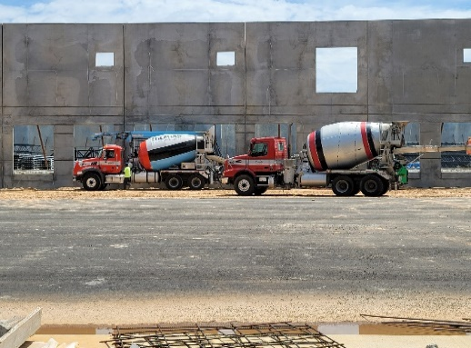

The following revenue sources make up the City’s revenue portfolio:

Taxes on Property:

Ad Valorem Tax
The ad valorem tax (or property tax) is an important component of municipal revenue. It provides a stable source of revenue for the City. Residents and non-resident taxpayers received a direct benefit for paying property tax. The City uses the tax revenue to fund its General Fund activities such as public safety, street maintenance and repair, parks and recreation, transportation enhancement projects, community development projects, and storm drain systems.

Taxation of Motor Vehicles
As allowed by the Georgia Constitution, motor vehicles are taxed in a manner that is different than the taxation of other property. The “birthday day” or annual ad valorem tax for motor vehicles was exempted in 2012 legislation and was implemented as a one-time tax that is imposed on the fair market value of the vehicle.

Alcoholic Beverage Excise Taxes
Taxes levied on distilled spirits (up to $.22 per liter on packaged sales and 3% of the sale price on sales by the drink), wine (up to $.22 per liter), and malt beverages (up to $6.00 per bulk container and up to $.05 per 12-ounce bottle, can, or other container).

Insurance Premium Taxes and License Fees
Insurance premium tax is a levy of 1% on life insurance companies based on gross premium on policies of persons living within the City’s jurisdiction. The City can levy a gross premium tax of no more than 2.5% on all other types of insurance companies. This tax is collected by the Georgia Commissioner of Insurance and is remitted to the City on an annual basis in October of every year. The City also imposed and collects license fees on insurance companies doing business within the City’s limits. By state statute, and through submission of the City’s ordinance adopting the imposition of insurance license fees, the City can impose a $25.00 fee on insurance companies. The fee is based on population.

Business and Occupation Taxes
The City levies and collects business and occupation taxes on businesses and practitioners with offices or locations within the City. Some types of business are exempt from this tax (i.e. non-profits). The City uses the “number of employees” method of taxation.

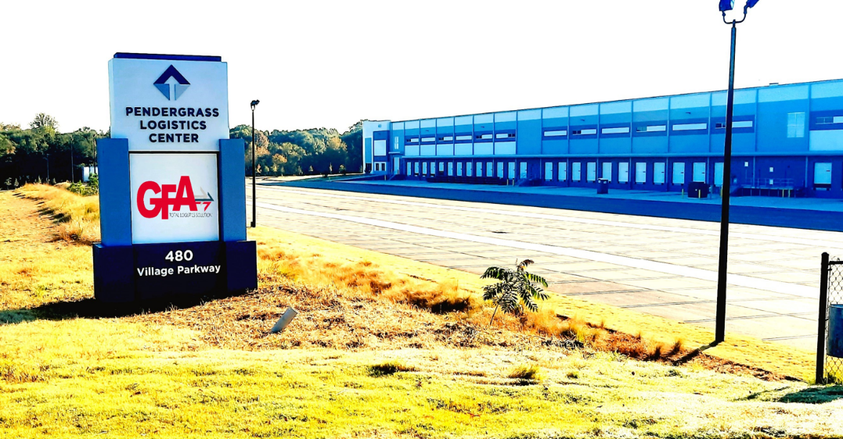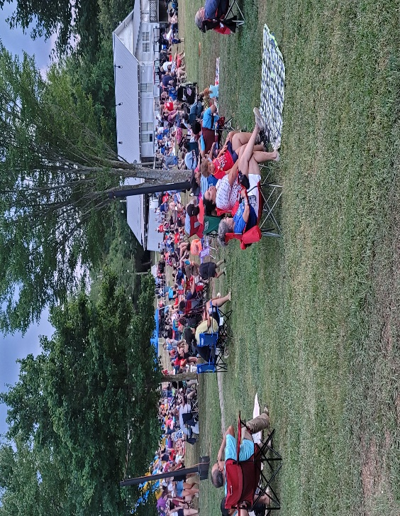

Franchise Fees
The City enters into franchise agreements or contracts with cable, electric, gas and telephone companies doing business in the City. These agreements determine the terms that a public utility company abides by when using the City’s right of way. The fee is most often a percentage of the utility’s gross receipts within the municipality. The electric franchise fee is remitted to the City annually, while gas, telephone and cable franchise fees are remitted quarterly.

Fines and Forfeitures, Court Fees, and Costs
This revenue includes traffic fines, fines from violations of the City Code, bonds posted to guarantee court appearances, and other court costs.



Alcoholic Beverage Licenses
The City requires that a person or business have a license from the City to sell alcohol, retail or wholesale, within the City. The amount of the fee, by license type, is established by resolution of the Council.

2024 BUDGET OVERVIEW
EXPENSES
COST CENTERS BUDGETS

Government:
Mayor $3,600.00
Council $14,400.00
City Attorney $7,500.00 $25,500.00

Municipal Court:
Judge $3,600.00
Associate Judge $2,800.00
Annual Training $2,100.00 $8,500.00

Public Safety:
Public Safety Salaries (Social Sec/Fica/Fed withhold) $627,360.00
Public Safety Supplies $37,500.00
Public Safety Repairs to Equipment $48,000.00
Public Safety Equipment/Uniforms/Ammunition, etc. $35,500.00
Public Safety Gasoline $65,000.00
Public Safety Annual Training $12,500.00
Animal Control $2,118.00 $827,978.00

Environmental Services:
Environmental Services Salaries $104,000.00
Environmental Services Supplies $105,000.00
Environmental Services Repairs $20,000.00
Environmental Services Equipment $7,500.00
Environmental Services Gasoline $15,000.00
Environmental Services Small Equipment $7,500.00
Uniforms $1,500.00
Contract Employees $120,000.00 $380,500.00

City Administrator:
City Administrator Salary – no benefits $85,000.00
Postage $150.00
Office Supplies $150.00 $85,300.00

Finance/ Human Resources Department:
Finance/ Human Resources Director Salary - no benefits $41,600.00
Postage $900.00
Office Supplies $5,500.00
Computer Software (city wide) $6,500.00 $54,500.00

City Hall/Library/ Court Services:
City Clerk/Court Clerk/Library Salary $49,920.00
Asst Clerk/Court Clerk/Library Salary $31,200.00
Postage $1,550.00
Office Supplies $5,000.00
Computer Software $3,500.00
GMA Annual Training $2,500.00
CJT Court System $16,000.00
GSCCA Fines and Fees to State $67,700.00
Local Victims State Payments $21,104.00
POA State Fund $25,251.00
POAB PD Dues $5,400.00 $229,124.00

Workers Compensation – All Employees $38,700.00
Health-Dental Vison – all Employees $210,000.00
Retirement – All Employees $32,000.00
Capital Debt Payment – City Hall/Library (annual) $36,000.00
Pest Control (entire city) $2,486.00
Peach State Fire extinguishers (vehicle and bldgs.) $2,500.00 $321,686.00
Communications- City Wide
Land lines/Internet $9,000.00
Mobile telephones $12,600.00 $21,600.00

Electricity
Street Lights $12,000.00
Environmental Services $3,200.00
Police $6,874.00
City Hall/Library $9,375.00
Park Lights $3,560.00 $35,009.00

Water (entire city usage) $8,709.00 $8,709.00

Advertising –
Public meetings, hearings, notices, etc. $2,500.00 $2,500.00

Annual Dues – GMA - $1,206.00 $1,206.00
General Liability Risk Insurance Premium
(grounds and vehicles) $58,317.00
Security Alarm Monitoring – Police Dept $1,200.00
Annual Backflow Device Test $500.00
Audit Service- Annual $16,895.00
Special Events – Christmas, 4th of July $15,000.00
Annual CSX Lease (Depot) $3,000.00
Tax Commissioners Office – Tax collection $12,000.00 $106, 912.00

TOTAL EXPENSES: $2,109,024.00

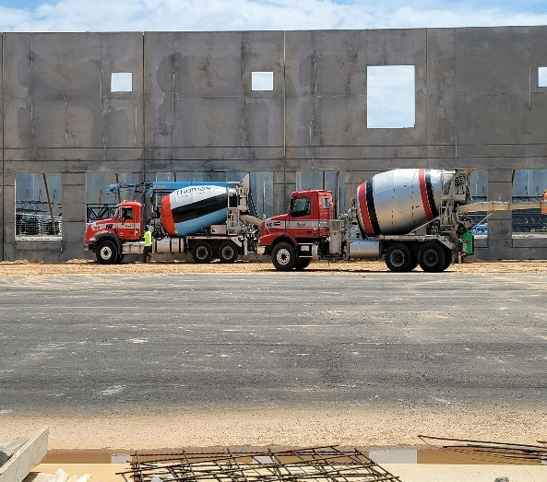

INCOME

2024 BUDGET OVERVIEW

REVENUE for the city consists of Property Taxes, County Sales Tax, Franchise fees, Excise fees and Other Revenues such as Licenses and Fees, Charges for Service, and Fines.

TOTAL TAXES AND FRANCHISE FEES ($1,606,000.00)
- Property Taxes – Property Taxes are proposed to generate about $662,000.00. The Jackson County Tax Commissioner sets the 2024 County tax digest.
- County Sales Tax – County wide sales tax income is projected to be $456,000.00. This L.O.S.T. percentage was negotiated with the county in 2022.
- Alcoholic Beverage Fees – These fees are projected to be $65,000.00.
- Franchise /Utilities/Enterprise Fees – are projected to generate $150,000.00
Electric $117,000.00
Gas $12,000.00
Cable $8,000.00
- Insurance Premium Fees - are projected to be $143,000.00 in 2024.
- Motor Vehicle TAVT Taxes – projected to be about $130,000.00 in 2024.

LICENSE AND PERMITS ($245,374.00)
- Planning and Building fees – Planning and Building Inspection fees for 2024 are projected to be about $240.374.00
- Signs Permits, Site Approvals, Plan Site Zoning costs – are projected to generate about $5000.00 in income for 2024.

MUNICIPAL COURT FINES ($220,000.00)
- Fines and Forfeitures from Police Services – are expected to generate about $220,000.00 in 2024.

CHARGES FOR SERVICES ($6,000.00)
- General Government fees (fees for services – copying, faxes, and permits) are expected to generate $6,000.

MISCELLANEOUS ($31,650.00)
- Sanitation fees – projected to be about $18,650.00.
- Probation fees – projected to be about $3,000.00.
- Municipal License fees – projected to be about $10,000.00.

TOTAL INCOME PROJECTED IN 2024 = $2,109.024.00

Vision Statement



Pendergrass is a progressive
city where we strive to:

•Promote a high quality of life

•Create a strong sense of community and place

•Respect our heritage while guiding our future

•Be the best place to call home

Organizational Chart

Pendergrass Citizens

Mayor &
City Council

City Administrator

City Attorney Municipal Judge

Administration Operations

Finance City Clerk

Human Resources Economic
Development
Budget Officer
Court Clerk
Audit
Police Services

Environmental
Services

Planning & Zoning
In Pendergrass’s form of government, the Mayor is the
Chief executive officer of the City government and the
presiding officer at City Council meetings, and is responsible
for the efficient and orderly administration of the City’s affairs.
The City Council serves as the legislative branch of municipal
government. Pendergrass’s elected officials and employees are
responsible for ensuring that the community’s vision for this city
is fulfilled and for developing policies and procedures necessary for
that community vision.


STATE OF GEORGIA
COUNTY OF JACKSON
CITY OF PENDERGRASS ORDINANCE 2023082923
A GEORGIA MUNICIPAL CORPORATION

PURSUANT TO THE PROVISIONS OF O.C.G.A. §36-81-1, ET AL, AN ORDINANCE TO ADOPT THE BUDGET FOR THE FISCAL YEAR BEGINNING JANUARY 01, 2024, AND ENDING DECEMBER 31, 2024, FOR EACH FUND OF THE CITY OF PENDERGRASS, GEORGIA. APPROPRIATING THE AMOUNTS SHOWN IN EACH BUDGET AS EXPENDITURES, ADOPTING THE ITEMS OF ANTICIPATED FUNDING SOURCES, PROVIDING FOR THE RECEIPT OF MONIES BY GIFT, GRANT OR OTHERWISE, AND OTHER ITEMS NECESSARY FOR THE ONGOING OPERATION FOR THE CITY OF PENDERGRASS, GEORIGA

WHEREAS, the Mayor has presented a proposed fiscal year 2024 Budget to the City Council; and

WHEREAS, sound governmental operations require a budget in order to plan the financing of services for the residents of the City of Pendergrass; and

WHEREAS, Title 36, Chapter 81, Article 1 of the Official Code of Georgia Annotated requires a balanced budget for the City’s fiscal year, which runs from January 01 to December 31 of each year; and

WHEREAS, the City Council has reviewed the proposed FY 2024 budget as presented by the Mayor: and

WHEREAS, the budget lists proposed expenditures and expenses for the fiscal year 2023; and

WHEREAS, this budget as presented is a balanced budget, so that anticipated revenues and other financial sources for each fund equal the proposed expenditures and expenses; and

WHEREAS, the City Council grants authority to the Mayor to adjust the budget as necessary for any gifts, donations, or grants that are accepted by the City Council during the fiscal year; and

WHEREAS, public hearings on the proposed budget were held at a Public Hearing held on August 11th, 2023, at 11:00 a.m.; on August 11th, 2023 at 6:30 p.m.; and again on August 29th, 2023, at 6:30 p.m.; and

WHEREAS, each of these budgets is a balanced budget, so that anticipated revenues for each fund equal or exceed proposed expenditures and expenses.

NOW THEREFORE BE IT, AND IT IS HEREBY ORDAINED by the Mayor and Council of the City of Pendergrass, and under the authority thereof that this budget, Attachment “A” hereto and incorporated as part of this Ordinance, shall be the City of Pendergrass’s budget for the fiscal year 2024.

FURTHERMORE, this Ordinance shall be and remain in full force and effect from and after its date of adoption.

This Ordinance having been properly considered and adopted by the City Council of the City of Pendergrass, Georgia, the same is hereby approved this _________ day of ____________ 2023.

SO ORDAINED, this _______ day of _____________, 2023.

Approved:

__________________________
Nicholas Geiman, Mayor

__________________________ __________________________
Councilman Councilman Willie Pittmon

__________________________ ___________________________
Councilman Nathan Pruitt Councilman Nick

__________________________ ___________________________
Councilwoman Councilwoman Tara Underwood

Approved as to form and content: Attest:

___________________________ ______________________________
City Attorney City Clerk

